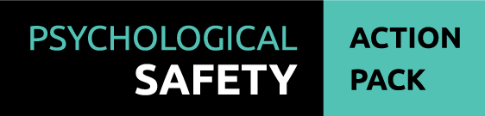

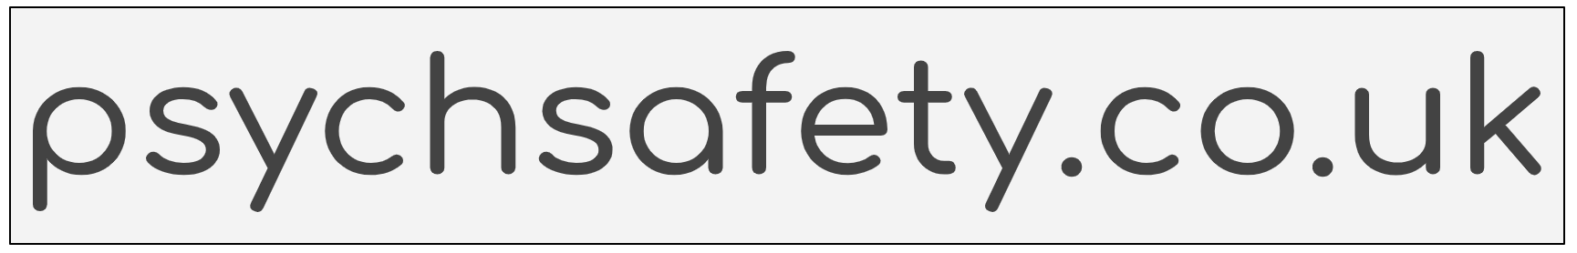

V1.1

**Welcome to the Psychological Safety Action Pack.**

Psychological safety is the most important factor in high performing teams, and high performing teams are happy.

Use this action pack as a resource to measure, build and maintain psychological safety in your teams. You may use the *Six Month Planner* (item 3) to develop a structured plan, or you may simply wish to use elements to complement your existing team building and leadership programmes.

This action pack contains background information, survey tools, guides, workshop templates, posters and other resources.

There are three phases to this process:

1. *Planning*
2. *Implementation*
3. *Reflection*

After reflection, you may loop back to Planning, and repeat the cycle to continue improving your own capability and the level of psychological safety in your team.

**Contents**:

1. Contents and Introduction
2. The Case for Psychological Safety
3. Six Month Planner
4. Measuring Psychological Safety
5. Post-Survey Action Guide
6. Values and Behaviours Workshop
7. Team Performance Workshop
8. The Fear Conversation Exercise
9. Team Retrospective Templates
10. Self-Coaching and Reflection Worksheet

**Additional Resources:**

1. Grace Hopper Leadership and Management Poster
2. “The 3 Fundamentals of Psychological Safety” Poster
3. Psychological Safety Checklist
4. Remote Psychological Safety Checklist
5. Tuckman’s Model of Team Development
6. “You don’t have to be told you’re a leader” Poster
7. The Psychological Safety Quadrant
8. The Fear Conversation Chart
9. The Four Stages of Psychological Safety
10. Organisational Culture and Westrum’s Typology
11. Mentorship and Coaching
12. Cognitive Load and Psychological Safety
13. Further Reading and References

**An Introduction to Psychological Safety**

In 1986, the Chernobyl power plant suffered a major disaster that directly killed 31 people and is estimated to have indirectly killed over 4000. Whilst the plant itself possessed an inherently unsafe design, the culture in Russia at the time did not encourage the raising of concerns or speaking up about mistakes. A fear of authority and the need to please political masters resulted in a fear-driven culture. During a simulated power shutdown, operators who were not fully equipped to deal with the situation made a series of protocol mistakes which resulted in a steam explosion, followed by a nuclear explosion. The cause of the disaster was in large part because operators did not speak up about their concerns.

Thirteen years later, Dr Amy Edmondson was studying clinical teams and the number of mistakes that different teams made. During her research she was surprised to find that the teams with a higher number of good outcomes actually made more mistakes than teams with fewer good outcomes. It was a surprising result, but after further investigation, Dr Edmondson discovered that in fact those teams with better outcomes were *admitting* more mistakes, whilst the teams with fewer good outcomes were more likely to *hide* theirs. As a result, Dr Edmondson formulated the concept of psychological safety, namely: the *belief that one will not be punished or humiliated for speaking up with ideas, questions, concerns, or mistakes*. She believed that psychological safety was a key factor in team performance.

Let’s relate this now to your own experience. Think about the best team you’ve been a member of. It could be a sports team, a business team, or some other group of people with a shared goal. Being a member of that team probably felt good, it may have even been energising and inspiring. Whilst the members of that team may well have been experts in their field, it’s likely that being a member of that team felt good because that team felt safe to be themselves. They, and you, likely felt free to admit mistakes, ask for help, and even challenge ideas from other team members without fear of humiliation or embarrassment.

Now think about one of the worst teams you’ve been a member of. Perhaps you felt that you had to put on a metaphorical “mask”, and be a different version of yourself in order to fit in. You may not have been able to admit mistakes, or ask for help, in case members of the team saw it as a weakness and used it against you. Chances are, you didn’t feel very “safe” in this team.

Think of these two teams when thinking about levels of psychological safety. Psychological safety isn’t a binary “on or off” factor, it’s a sliding scale. Teams (and members of those teams) possess it to varying degrees. The best team you’ve been on probably possessed a lot, whilst the worst probably did not possess much at all. This pack will support you to increase the psychological safety experienced by your team right now.

**Leadership vs Management**

At times through this action pack, we will refer to both “leadership” and “management”. It’s important to recognise the difference between these two practices. The indubitable Grace Hopper once stated that “You manage *things*, you lead *people*.” What she meant is that management consists of all the processes, tools, and controls that need to exist in order for people to work effectively, whilst leadership is far larger in scope and consists of, for example, setting direction, making strategic decisions, supporting and motivating people, and elevating people in order to reach their highest potential. (See *Grace Hopper - Management and Leadership* (item A))

In practice, this means that neither management nor leadership can be neglected. In order for people to perform well, they need to operate in environments where safety, costs, tools and processes are managed effectively. A team cannot deliver if they do not know *how*, or indeed *what* to deliver. Management is therefore part of leadership, and contributes to the “structure and clarity” that Google’s Project Aristotle defined as the third most important factor in high performing teams. Incidentally, guess what the most important factor they identified was? Yes, exactly. Psychological safety. More on this to come in *The Case For Psychological Safety* (item 2)

**The Four Stages of Psychological Safety**

Timothy R Clarke in his book “The Four Stages Of Psychological Safety” described four stages of psychological safety that teams can move through, progressing from stage 1 to stage 4. These are:

(1) Inclusion Safety - members feel safe to belong to the team

(2) Learner Safety - members are able to learn through asking questions

(3) Contributor Safety - members feel safe to contribute their own ideas

(4) Challenger Safety - members can question others’ ideas or suggest significant changes

Another useful model for team development is *Tuckman’s Model of Team Development* (item E), where teams “Form”, “Storm”, “Norm”, and finally, “Perform”. It is only in psychologically safe teams that true performance will be reached, since this stage requires the ability for team members to admit and learn from mistakes, and to contribute and challenge ideas. Reaching this stage, as a leader of a team, is your goal.

**The Three Fundamentals**

There are three core leadership behaviours (*The Three Fundamentals of Psychological Safety* (item B)) which support psychological safety in teams. These may seem simple, but in practice they extend to every single leadership behaviour and every single aspect of communication. Those three core behaviours are:

* **Framing work as a learning problem**, not an execution problem. The outcome of work should not exclusively be the output; it must also be learning how to do it better next time.
* **Acknowledging your own fallibility**. By admitting when you make a mistake or don’t know the answer, you allow (indeed, encourage) others to do the same.
* **Modelling curiosity and asking questions**. Stay curious, ask other people what they think, and ask them to contribute. By asking questions and asking for help, you’re creating a space and a need for people to speak up, which is essential for psychological safety and for high performing teams.

I hope you get a lot of value from this action pack, and enjoy the process.

For assistance running workshops, or for further information about concepts introduced in this action pack or anything else, please get in touch: [tom@tomgeraghty.co.uk](mailto:tom@tomgeraghty.co.uk)

This action pack is licensed under a [Creative Commons Attribution-NonCommercial-ShareAlike 4.0 International License](http://creativecommons.org/licenses/by-nc-sa/4.0/).